1.母报表打开页面：

默认参数当月的第一天到现在 图1-1

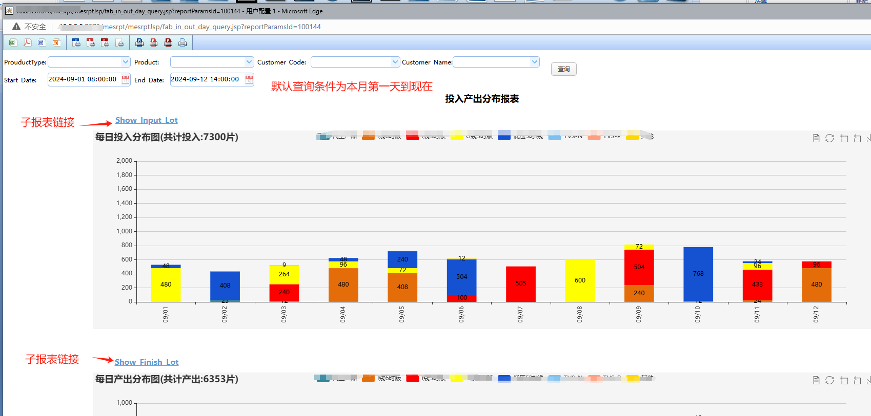

2.子报表打开页面：

沿用母报表查询参数 图1-2

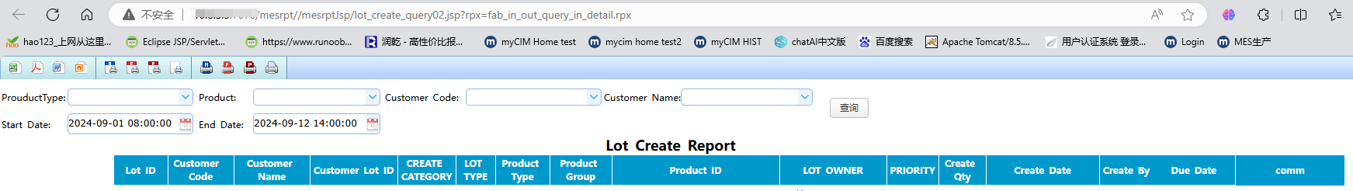

3.母报表修改查询条件：

例如start date为8月1日 图1-3

母报表查询结果按参数变更生效。

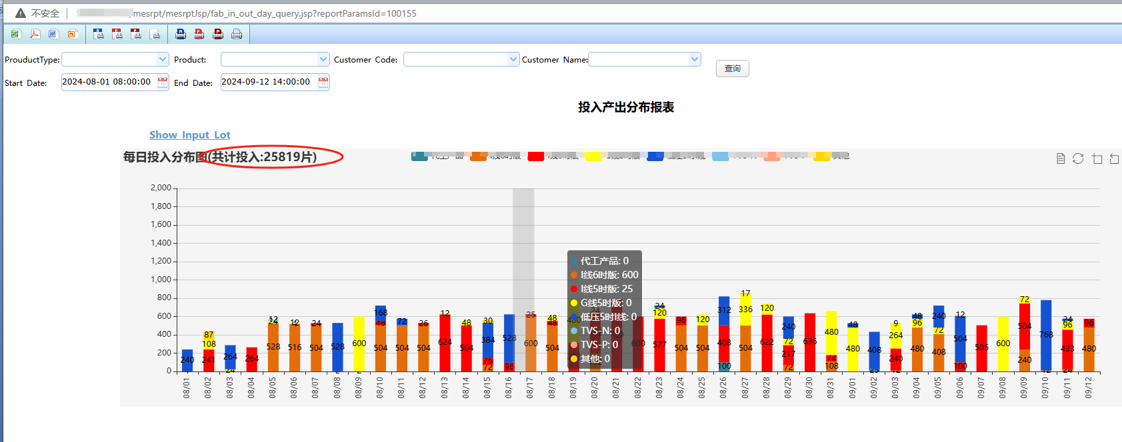

但是点击子报表 仍为图1-2内容

4.母表对应JSP文件：

<%

String oldRpxHome = Context.getInitCtx().getMainDir();

String oldDfxHome = Env.getMainPath();

String report = "/fa/rpt/fab_in_out_day_query.rpx"; //request.getParameter( "__rpx" );

//String rpxHome = request.getParameter( "__rpxHome" );

//String dfxHome = request.getParameter( "__dfxHome" );

Context.getInitCtx().setMainDir( rpxHome );

Env.setMainPath( dfxHome );

try {

String argRpx ="/fa/rpt/fab_in_out_query_arg.rpx"; ;

%>

5.子报表对应JSP文件：

<%

String oldRpxHome = Context.getInitCtx().getMainDir();

String oldDfxHome = Env.getMainPath();

String report = "/fa/rpt/fab_in_out_query_in_detail.rpx"; //request.getParameter( "__rpx" );

//String rpxHome = request.getParameter( "__rpxHome" );

//String dfxHome = request.getParameter( "__dfxHome" );

Context.getInitCtx().setMainDir( rpxHome );

Env.setMainPath( dfxHome );

try {

String argRpx ="/fa/rpt/fab_in_out_query_arg.rpx"; ; --此处沿用母表的arg文件

%>

6.母表arg数据集 : 图1-4

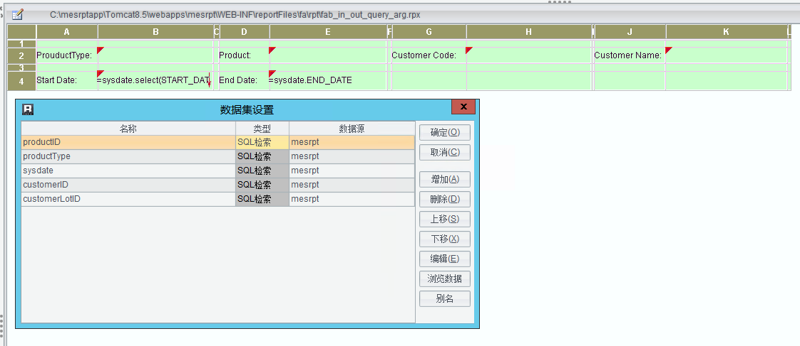

7.子表主体部分数据集 图1-5

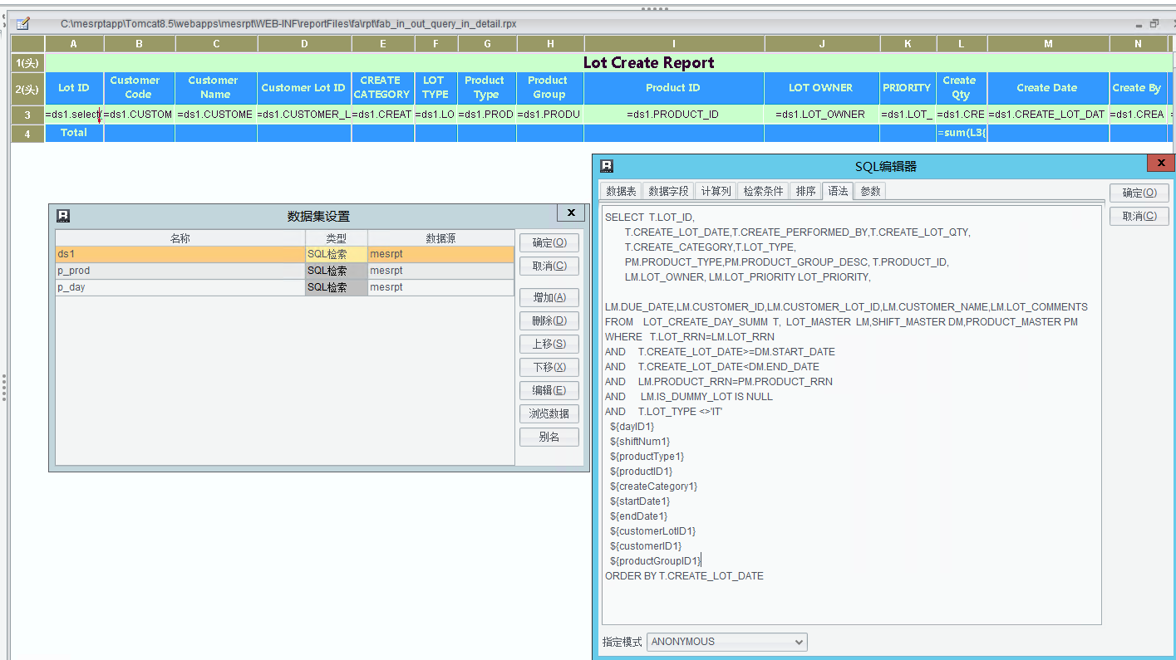

7.1

ds1: SELECT T.LOT_ID, T.CREATE_LOT_DATE,T.CREATE_PERFORMED_BY,T.CREATE_LOT_QTY,

T.CREATE_CATEGORY,T.LOT_TYPE,PM.PRODUCT_TYPE,PM.PRODUCT_GROUP_DESC, T.PRODUCT_ID, LM.LOT_OWNER, LM.LOT_PRIORITY LOT_PRIORITY, LM.DUE_DATE,LM.CUSTOMER_ID,LM.CUSTOMER_LOT_ID,LM.CUSTOMER_NAME,LM.LOT_COMMENTS

FROM LOT_CREATE_DAY_SUMM T, LOT_MASTER LM,SHIFT_MASTER DM,PRODUCT_MASTER PM

WHERE T.LOT_RRN=LM.LOT_RRN

AND T.CREATE_LOT_DATE>=DM.START_DATE

AND T.CREATE_LOT_DATE<DM.END_DATE

AND LM.PRODUCT_RRN=PM.PRODUCT_RRN

AND LM.IS_DUMMY_LOT IS NULL

AND T.LOT_TYPE <>'IT'

${dayID1}

${shiftNum1}

${productType1}

${productID1}

${createCategory1}

${startDate1}

${endDate1}

${customerLotID1}

${customerID1}

${productGroupID1}

ORDER BY T.CREATE_LOT_DATE

7.2

Prod:

SELECT DISTINCT PRODUCT_GROUP_ID,PRODUCT_GROUP_DESC FROM PRODUCT_MASTER

WHERE PRODUCT_GROUP_ID IS NOT NULL

ORDER BY PRODUCT_GROUP_ID

7.3

P_day:

SELECT CALENDAR_DATE,TO_CHAR(CALENDAR_DATE,'YYYY-MM-DD HH24:MI:SS') DAY_ID

FROM DAY_MASTER DM

WHERE 1=1

${dayID1}

--'MM/DD'

ORDER BY CALENDAR_DATE